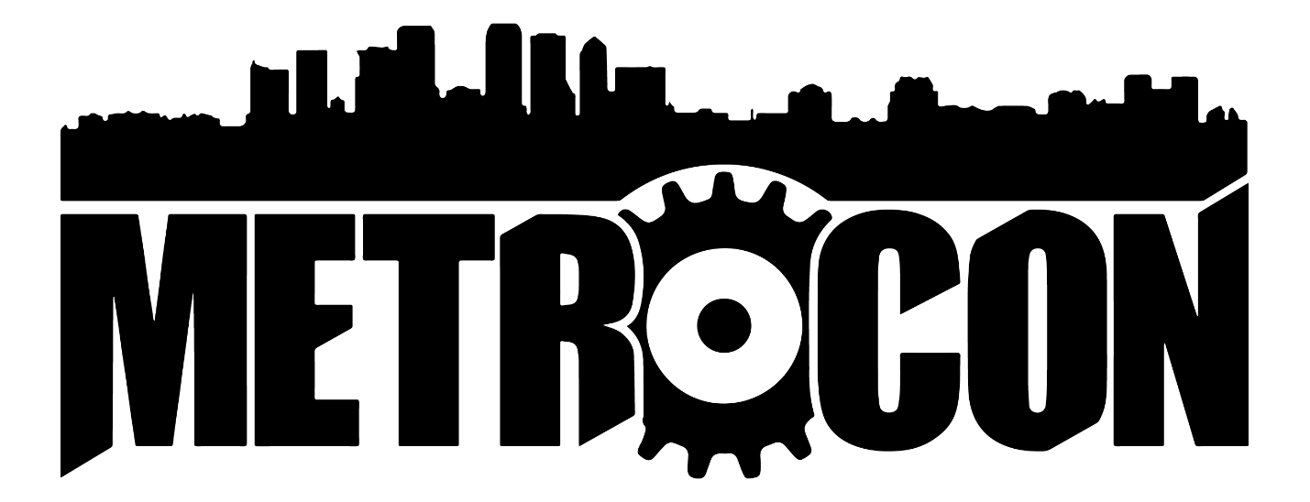
METROMascot 2019 Art Contest Entry Form

Name:
Alias:
(List if you do not want your legal name listed in public.)

Phone Number:
Email:

Name of Submission  (Please title each submission and corresponding files) | Type of Art  (Digital/Clay/Ink/Cosplay/Etc.) | Artist Notes
1)
2)

PLEASE MAKE SURE: (Checklist)
- Have you included all four main mascots in your entry? (You must include all four to be eligible for top prizes) ___
- Did you submit two entries? ___
- Did you include any bonus METROCON characters? (IE: Team Dynamite Department heads, staff members, Brute Squad, Gear Sprites, Gate Keeper, etc.)? ___
- Is your entry finished the way YOU wanted it to be? ___
- If you had any questions, did you email and ask metroteamcosplay@gmail.com? ___

Signature: Date: __/__/__

