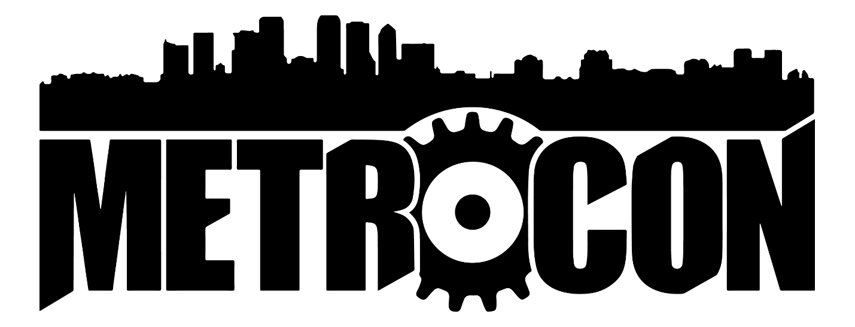

Picture This! Contest Registration
Legal Name
Alias/Stage Name
Phone Number
Email

Entry Information
Entry Title | Equipment | Location/Date | Character/Series | Edited? Yes/No
1)
2)
3)
4)
5)

Additional Comments
Entry 1
Entry 2
Entry 3
Entry 4
Entry 5

By submitting this form, you agree that you have read and understand ALL of the rules of the 2019 METROCON Picture This! Photo contest. Once submitted an entry cannot be revoked by the entrant. METROCON Judges reserve the right to void or disqualify an entry for any reason at the sole discretion of the METROCON Judges.

