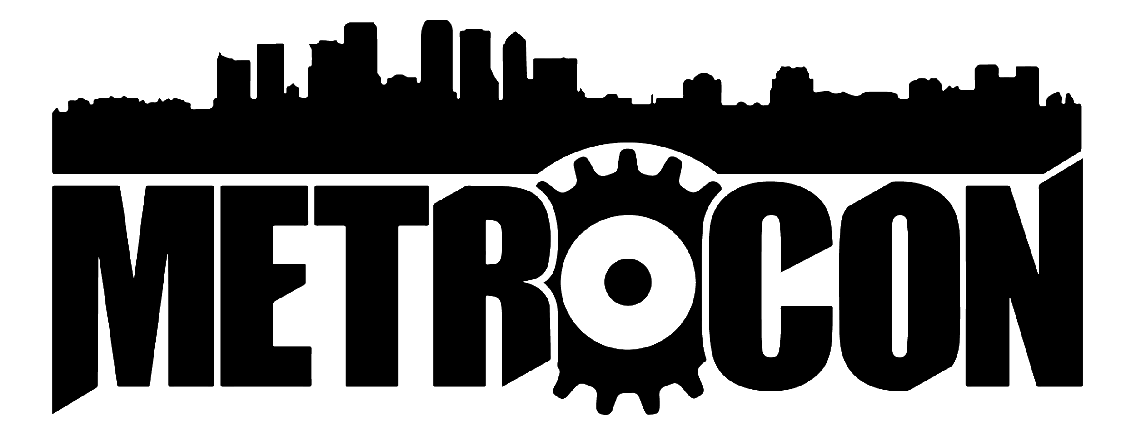
ENTRY #
Theme of AMV:
(for judges to fill out not for entrants)
________________________
________________________
________________________
AMV Convention Showing:
Saturday July 13th 2019
Main Events 3pm-4:30pm

2019 AMV CONTEST ENTRY FORM
Legal Name:

Alias (List only if you do not want legal name revealed to public. Legal name still required on entry form.):

Name of AMV(S) Submitted:  (list each AMV individually) | Type of AMV: (Drama/Comedy/Action/etc) | Series Used in AMV:
1.

2.
3.

PLEASE MAKE SURE: (Checklist)
- Do you have a 5 sec. Bumper? __
- Do you have a title Page in your AMV?__
- Did you make sure your format used listed in the rules page as acceptable?__
- Did you make sure to export your file in a high enough resolution listed on rules page? __
- Did you try to use mostly if not all NON subtitle embedded footage? __
- Did you have fun making this video? __ ^_^
- If you had any questions, did you email and ask METRO Team Cosplay Staff? __

Signature: ______________________ Email: ______________________________________
By signing this form you agree that you and all your group members have read and understood the rules of the 2019 METROCON AMV Contest. If submitting online, your email will serve as your electronic signature agreeing to all rules of the METROCON AMV Contest.

