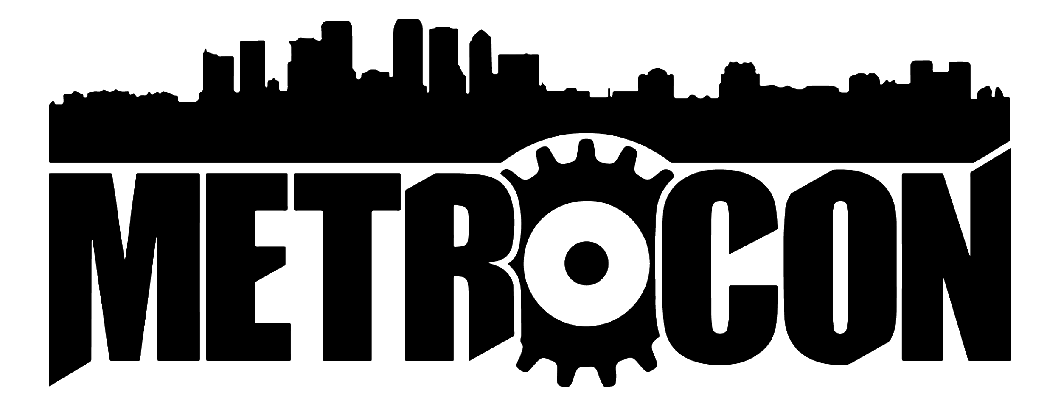
ENTRY #
Performance Pre Approval:
(for judges to fill out not for entrants)
________________________
________________________

Animation Idol:
Friday July 12th 2019
Special Events 12:00pm-2:00pm
2019 Animation Idol: ENTRY FORM
- Name(s) (LEGAL NAME ONLY) of Entrant (*Mandatory*) (LIST ALL MEMBERS Performing)

____________________________________________________________________________

- Alias (List ONLY if you DO NOT want your legal name revealed to the public):
(But you MUST provide your Legal name above for our convention records!)
______________________________________________
Name of Song(S) Submitted:  (list each song individually) | Original Artist Name:  Series/Movie Song is From: | Language of Song(s) Listed:

PLEASE MAKE SURE: (Checklist)
- You have chosen PG13 or below that rating type of song (No F bombs, very limited cursing allowed) ___
- You Pick a song within your vocal range? ___
- You memorize the Lyrics? ___
- You name your MP3 File: “YourNAMEYourSONG”.MP3 ? ___
- You have fun being Creative? ___
- If You had any questions, did you email and ask METRO Team Cosplay Staff BEFORE SUBMITTING? ___
- You email your MP3/MP3’s and your Entry form to Team Cosplay Staff Email?___
**Your CELL PHONE NUMBER (you will get a text if you do not show up on time Friday): ______________________________________________
Signature: ______________________ Email: ______________________________________
By signing this form you agree that you and all your group members have read and understood the rules of the 2019 METROCON Animation Idol. If submitting online, your email will serve as your electronic signature agreeing to all rules of the METROCON Animation Idol.

